SOCIAL ANALYTICS

ASSIGNMENT 1

Exploring SECOND LIFE

Name – Vinit Sukhani

500062842

R100217089

OSS B3

STEPS FOR INSTALLATION

1. First we need to download the second life installer from the official website after making an account on the same.

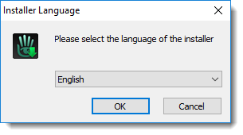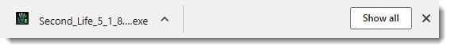 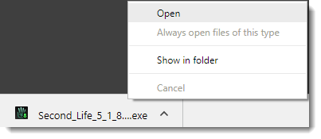

1. After Successful download we need to extract and install the file to our desired location.

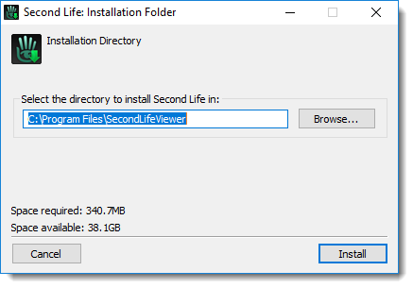

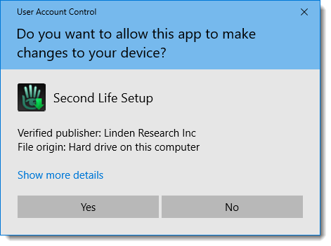

1. After installation, run the application which will ask for the user credentials upon landing on the welcome page.

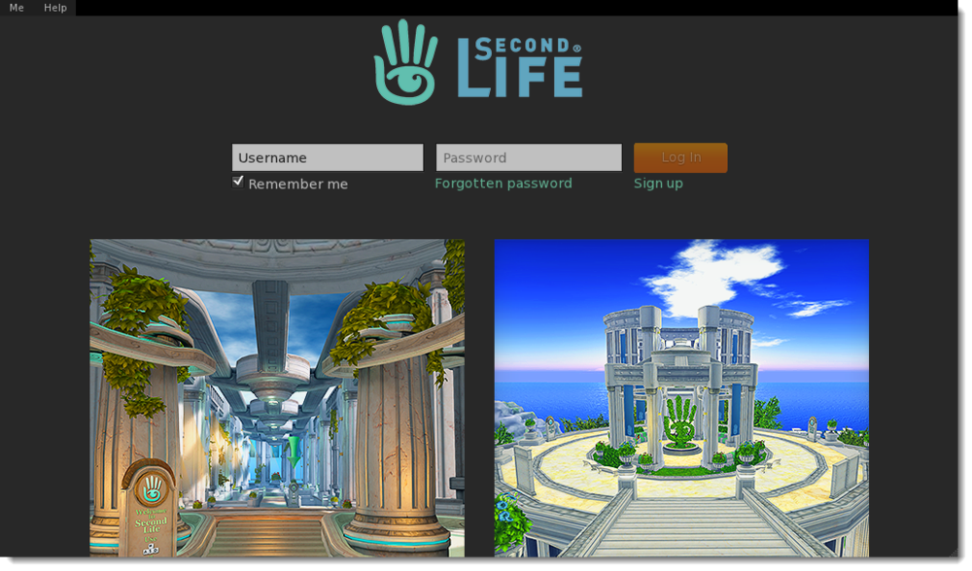

AVATAR SETUP

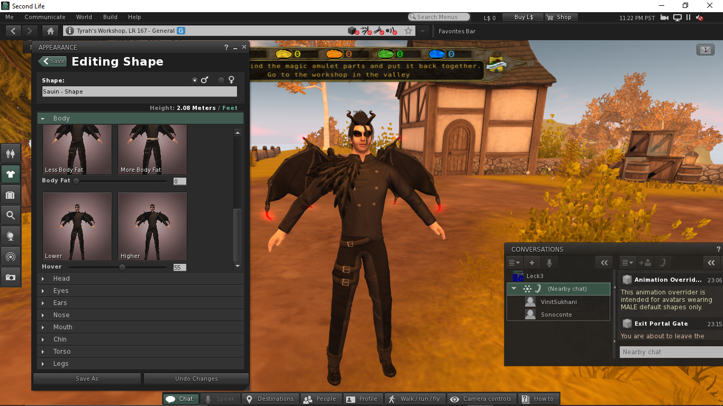

We can choose from a list of avatars and customize them as per our will.

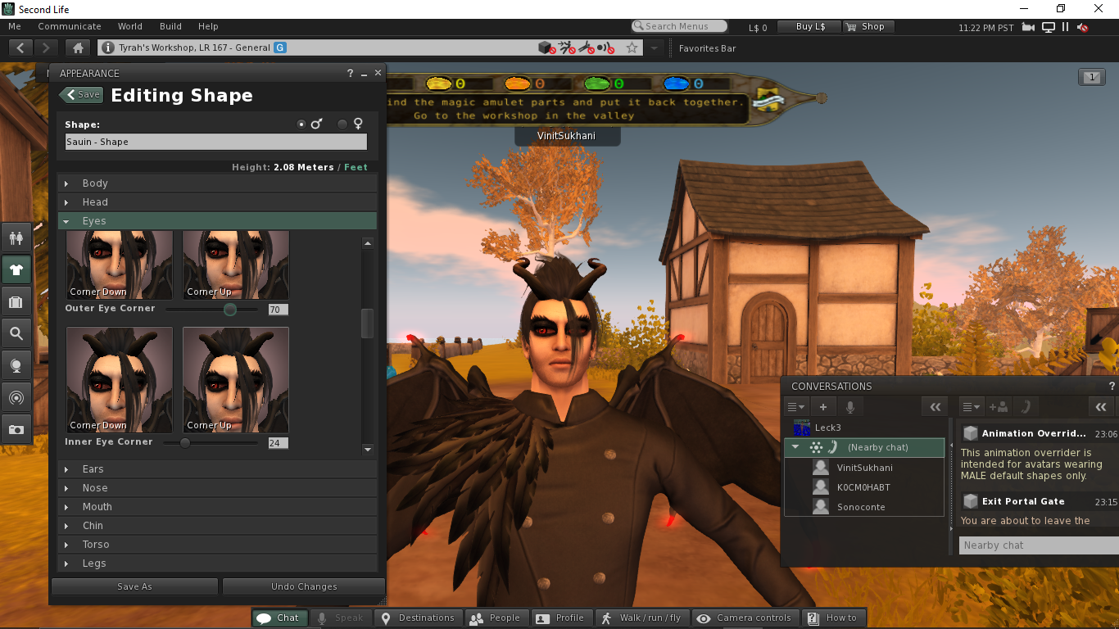

For my setup, I have chosen an avatar from the Vampire category as I have an interest in horror thrillers. There are 4 main categories namely New Avatars, Fantasy, Vampire and classic.

In the next steps I have used Avatar Editor to edit/ customize the details of my avatar for e.g. hair, clothes, shape, body style and other physical features.

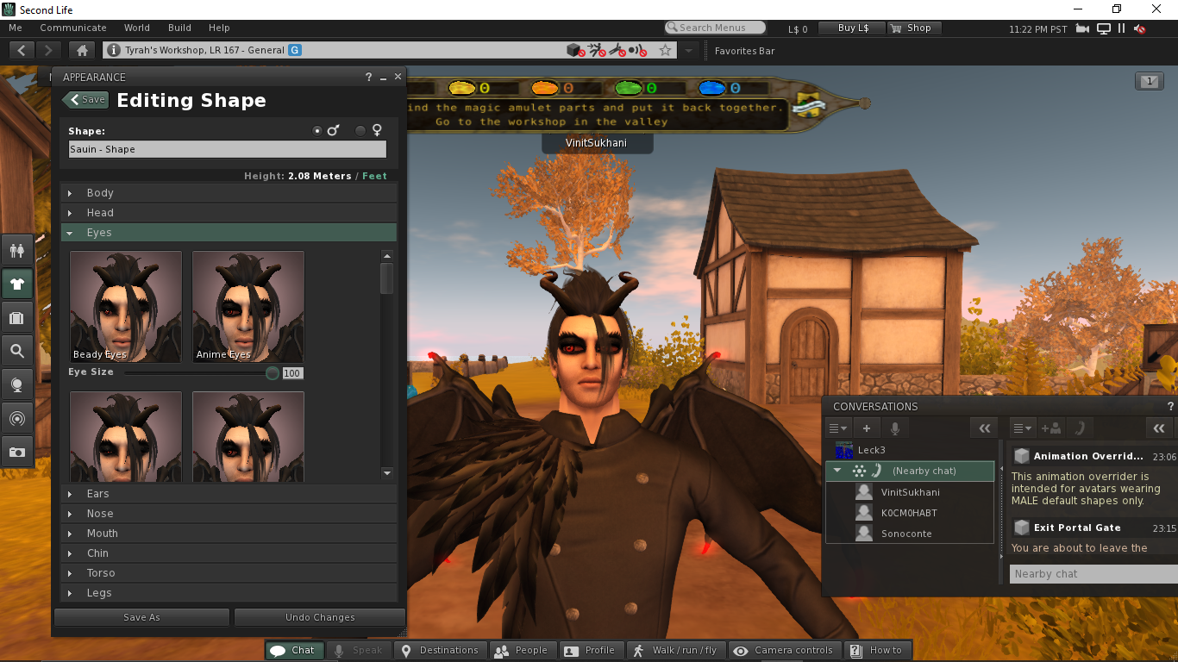

Eyes Customization

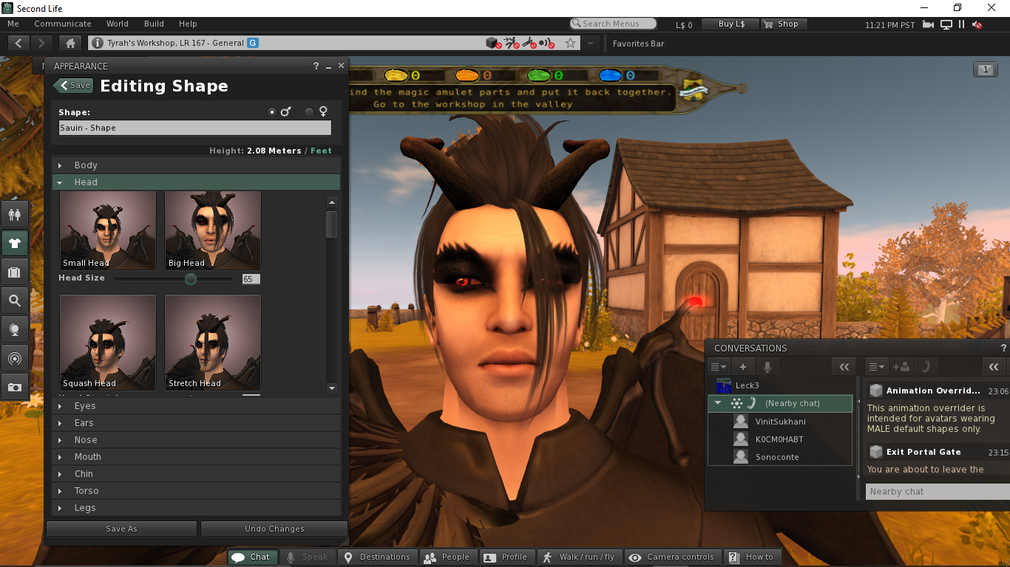

Head customization

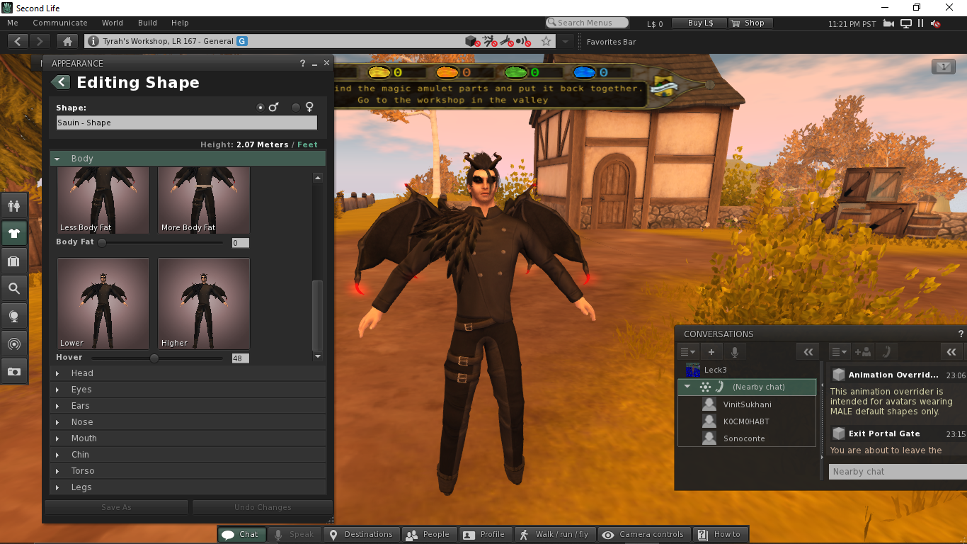

Body Customization

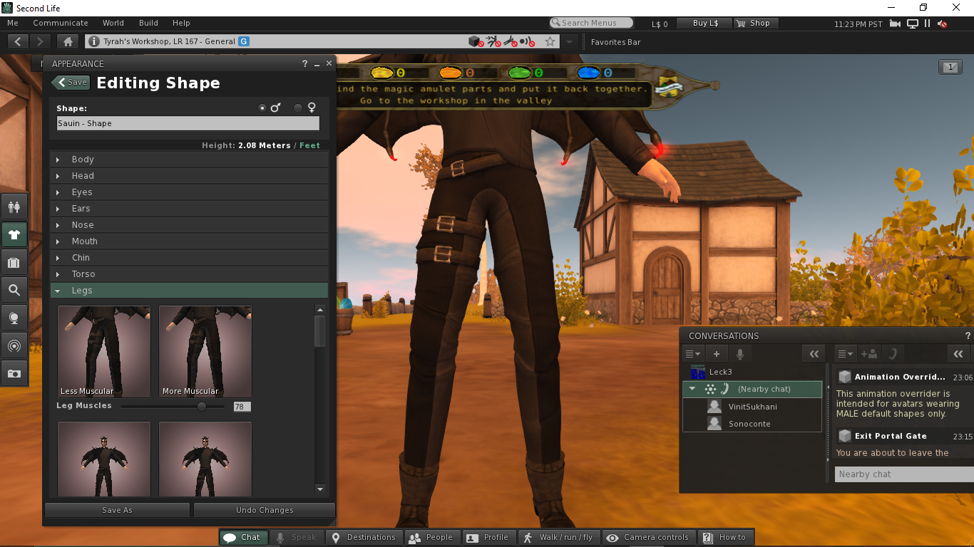

Legs Customization

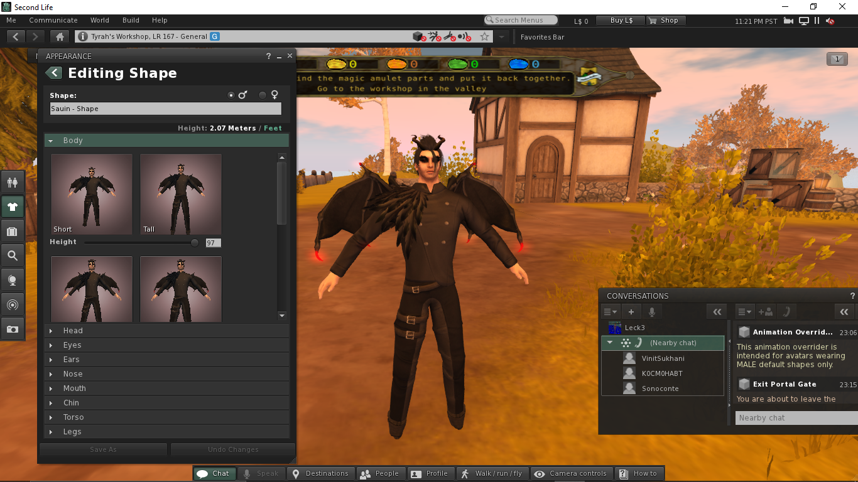

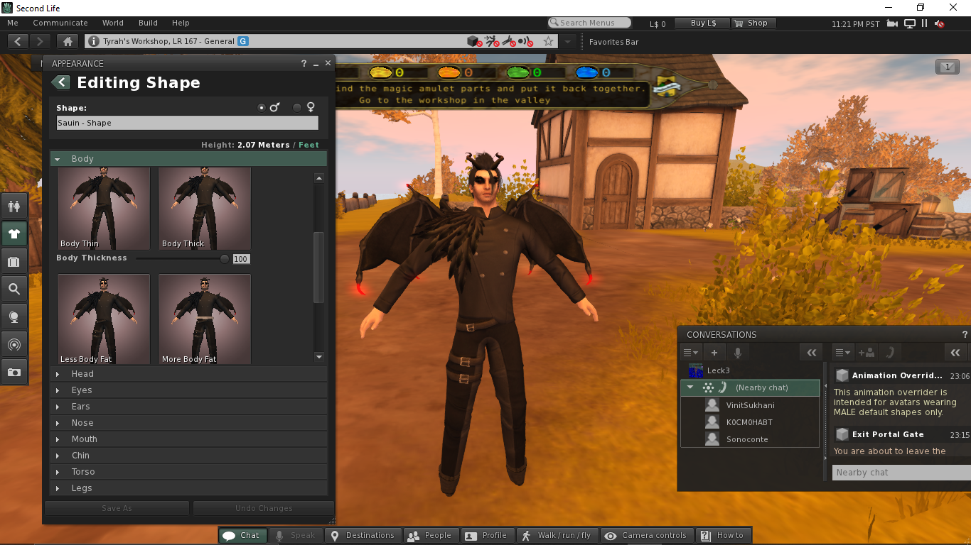

Body Customization

GAMEPLAY AND CONTROLS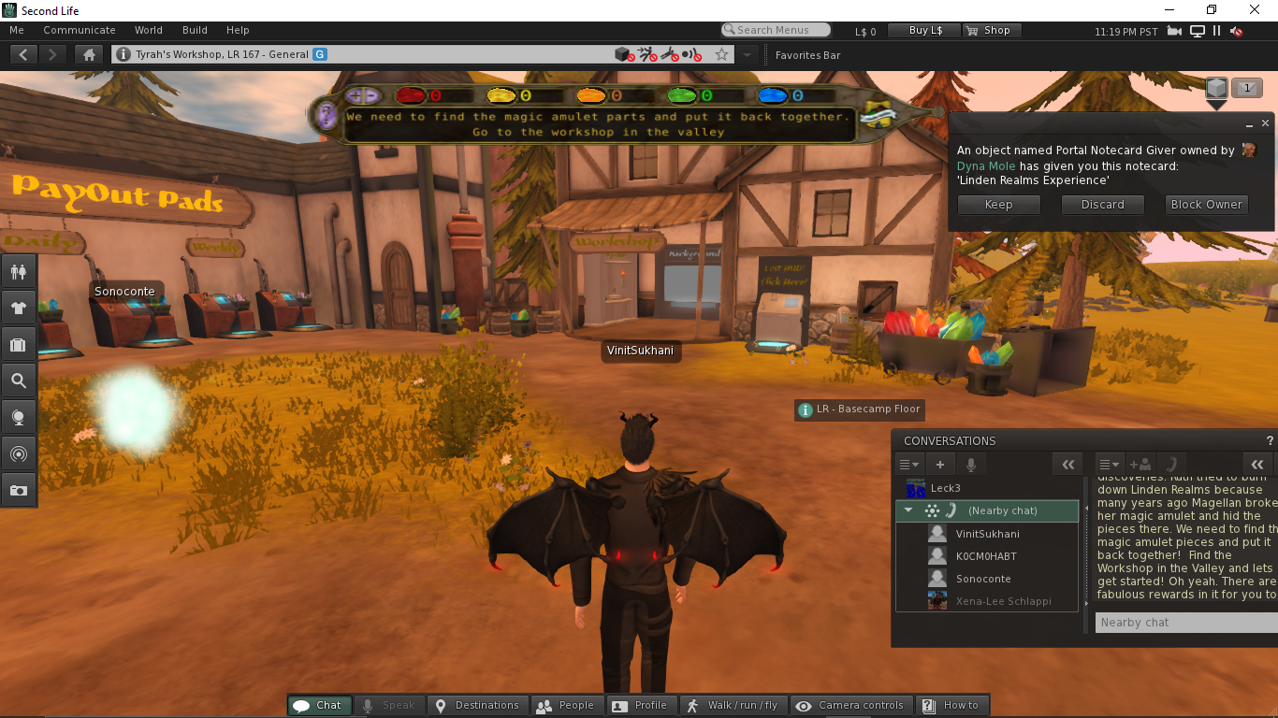

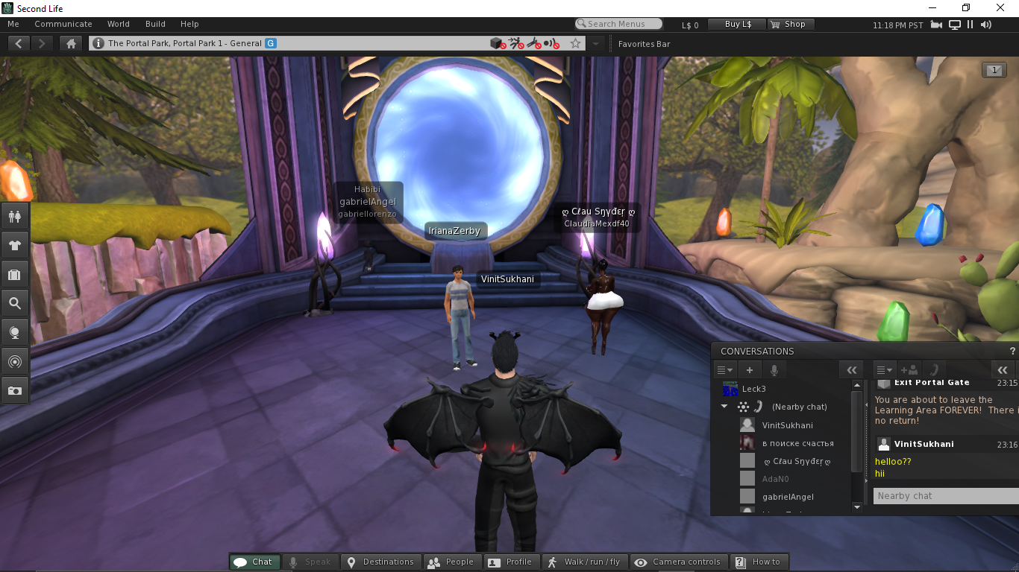

There are several locations to choose from, each location has a different theme and layout. Locations can either be accessed through the search bar or it can also be pinpointed on the world map. The application allows us to teleport to any location of our choice.

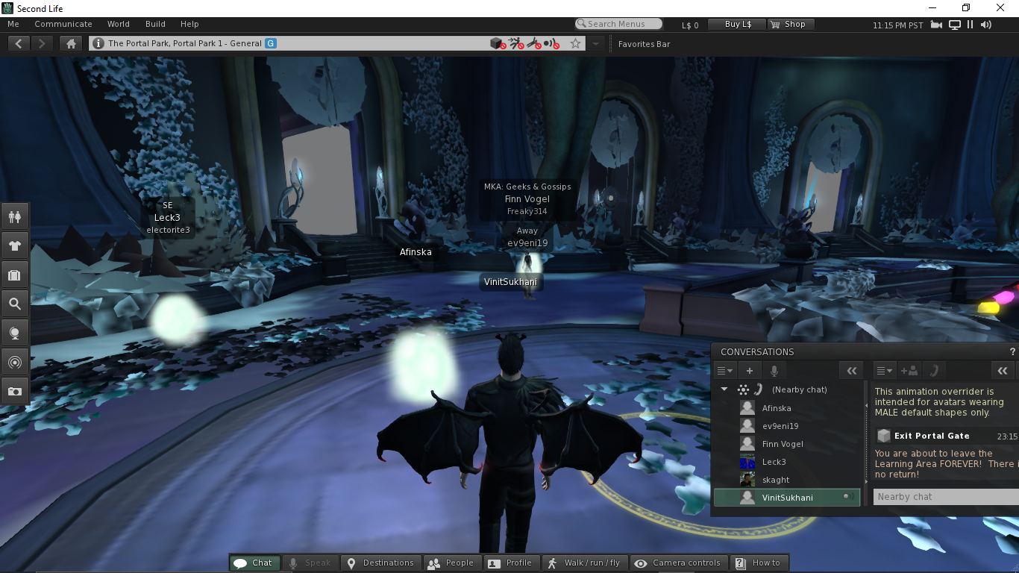

Second Life also provides us the feature of live interaction. We can use the chat icon to access the chat box which will allow us to chat with other players present in our vicinity.

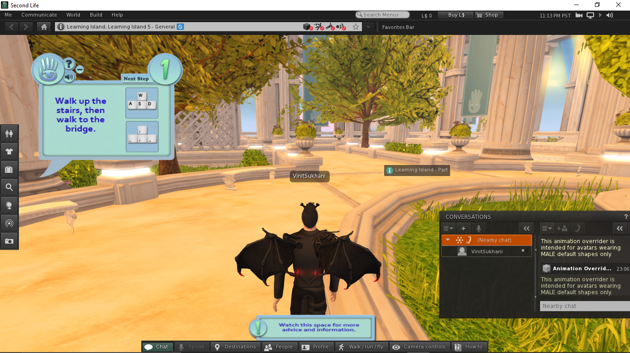

The movement of the character can be controlled by the W,A,S,D/ arrow keys.

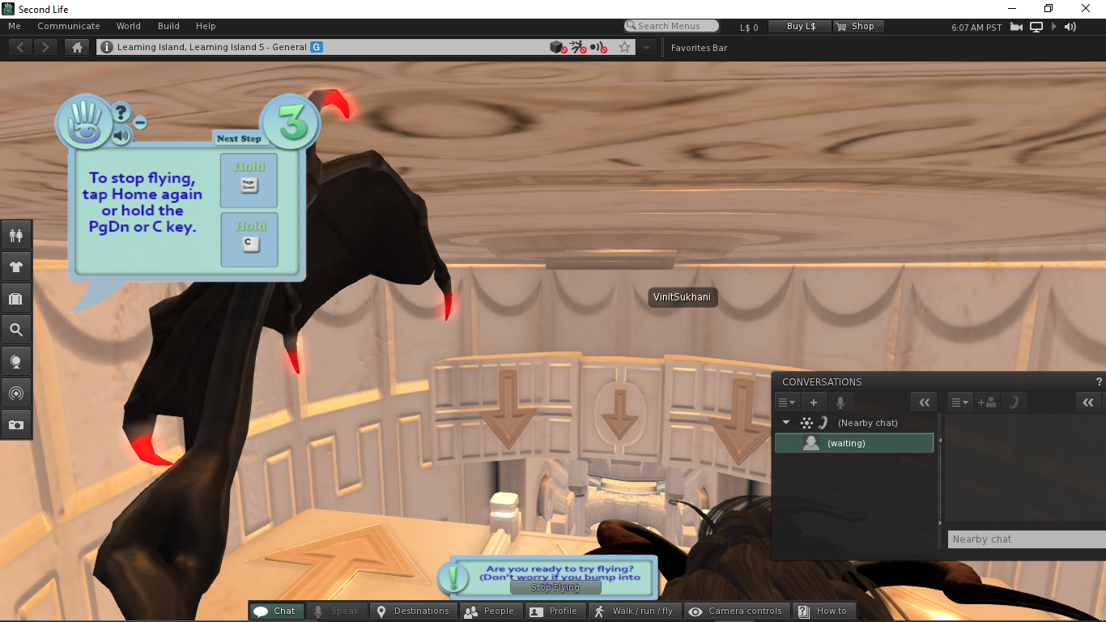

The E or PgUp key can be used to fly/jump /slide in upward direction. Similarly, to stop flying use PgDn or C key on the keyboard.

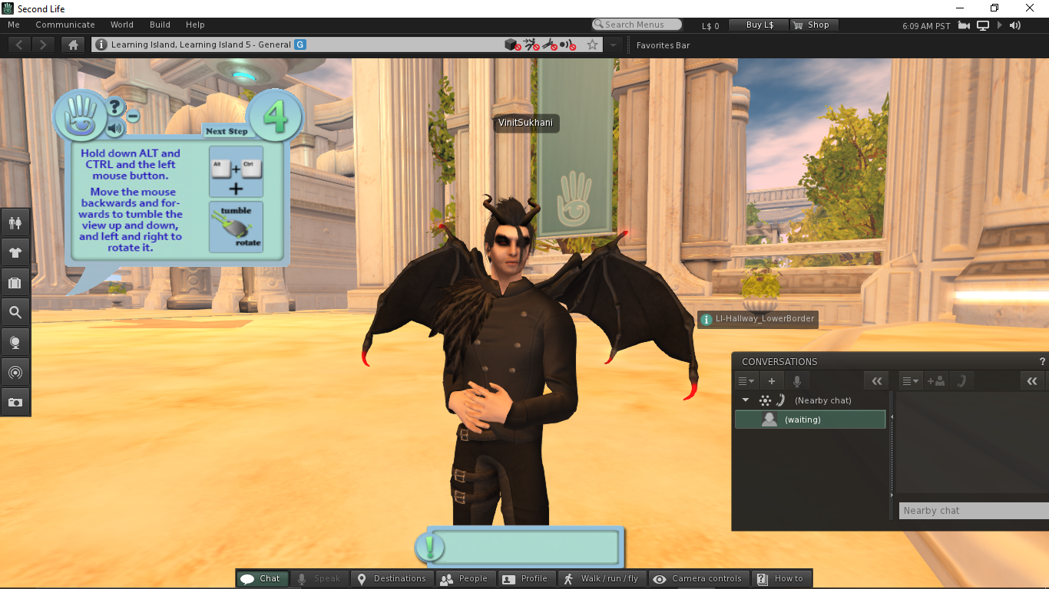

We can use a combination of Alt/CTRL and Mouse drag to pan the camera to a wider angle and to also change the viewing angle. We also have an option to switch between first/third person views.